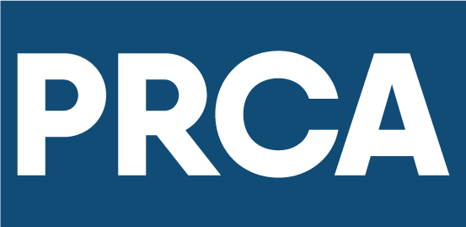ACCESSIBLE COMMUNICATIONS GUIDELINES

*2023 edition*

# TABLE OF CONTENTS

TABLE OF CONTENTS 2

FOREWORD by Renna Markson MPRCA Managing Director of PRCA 3

EXECUTIVE SUMMARY 5

PRCA ACCESSIBLE COMMUNICATIONS MANIFESTO 6

SECTION 1 – THE IMPERATIVE FOR CHANGE 7

COMMUNICATING INCLUSIVELY IS BOTH MORALLY AND COMMERCIALLY THE RIGHT THING 7

A SYMBOL FOR CHANGE 9

“Nothing for us without us” 9

Meet Hannah Diviney 10

UNDERSTANDING THE LIVED EXPERIENCE OF CONSUMING MEDIA AND CONTENT 11

SECTION 2 – HOW COMMUNICATORS CAN MAKE A DIFFERENCE 13

DISABILITIES AND THE IMPLICATIONS FOR ACCESSIBLE COMMUNICATIONS 13

WHAT THESE GUIDELINES COVER 15

SECTION 3 – DEVELOPING ACCESSIBLE CONTENT AND CAMPAIGNS 16

TYPES OF CONTENT 16

VISUAL CONTENT 17

IMAGES 17

LOGOS AND BRAND IDENTITY 20

VIDEO AND ANIMATED GRAPHICS 22

TEXT AND WRITTEN COPY 25

SOCIAL MEDIA CONTENT 30

FACEBOOK 31

INSTAGRAM 32

LINKEDIN 33

TIKTOK 34

TWITTER 34

INFLUENCER CONTENT 36

PHYSICAL AND VIRTUAL EVENTS 37

HELPFUL TIPS AND TOOLS 40

MICROSOFT ACCESSIBILITY CHECKER 40

MICROSOFT COLOR CONTRAST ANALYZER 42

WINDOWS SCREEN READER 43

SECTION 4 – EMBEDDING ACCESSIBILITY INTO YOUR COMMUNICATIONS FUNCTION 45

BEST PRACTICE 45

What does best practice look like? 45

CHECKLIST 49

# FOREWORD **by Renna Markson MPRCA** Managing Director of PRCA

As professional communicators, it is incumbent on us to make communications inclusive for people of all abilities so we can reach every member of society. Today, however, our industry falls short.

One in eight people globally has some form of disability. And every day they struggle to access content and communications from brands and organisations of all kinds.

They are excluded by default or by design.

It’s time we changed this.

Our guidelines for Accessible Communications have been updated for 2023, to include better representation in imagery and through language use, navigating social media channels, and how to better cater to accessibility requirements at both physical and virtual events**.**

This 3rd edition is designed to help every member of the PRCA, and the industry beyond, to create more inclusive content, campaigns, and experiences. The technology and tools to help us do this are readily available. The key priority is to update the way we work to adhere to best practices laid out in this document.

**Importantly, we are really excited to announce that the guidelines are now available for free in braille format. If you would like to request a braille version, please contact** [hello@accessible-communications.com](mailto:hello@accessible-communications.com) **to place your order.**

Current Global launched its Accessible by Design offer in 2020, anchored by a commitment that every piece of communication it develops, curates or publishes on behalf of itself and its clients will meet the highest accessibility standards. At the PRCA, we want to recognise Current Global for being the first global agency to make such a commitment, and for partnering with us to develop these guidelines and help instigate change across the industry. Current Global has been widely recognised for transforming what started as an internal initiative to become an industry movement, and since its launch, has persuaded organisations representing over 22,000 communications practitioners around the world to make that change too.

Together, we can make communications accessible for all.

# EXECUTIVE SUMMARY

The PRCA is strongly committed to Diversity and Inclusion.

These guidelines have been launched to further that priority commitment, with the goal of accelerating industry change to a point where all communications content and campaigns are accessible to people of all abilities.

This document is designed to help organisations and professionals gain a better understanding of the importance of accessible communications, and to equip them with practical tools, best practices and step-by-step processes to do so.

There are different forms of disabilities, but those most directly connected to and impacted by the accessibility of communications content and campaigns are: Visual, Hearing, Cognitive and Speech. These guidelines break down the different kinds of content and work typically produced by the communications industry, and the key considerations for making them accessible for people with disabilities in these four categories.

Lastly, this document includes some advice on embedding accessibility in the working practices of your communications function or organisation.

**Note: These guidelines do not affect the responsibility of PRCA members to do their own due diligence to ensure compliance with statutory requirements on accessibility which may vary from country to country.**

# PRCA ACCESSIBLE COMMUNICATIONS MANIFESTO

The PRCA’s goal is to ensure the industry operates to the very highest accessibility standards so that communications are inclusive for people of all abilities.

**What do we believe?**

* **No one should be excluded by default or design based on their ability.**
* **Inclusive communications are vital for a fairer, more equitable society.**
* **We have a responsibility to make the issue of inclusion more visible and to lead by example.**

**What do we want?**

* For agency and in-house executives to lead from the top and help instigate industry change.
* To elevate accessibility as a board-level issue every brand and organisation needs to prioritise.
* For every professional to make a personal commitment to produce accessible communications.

**How do we get there?**

* Make accessibility a core requirement of every piece of communications content or campaign.
* Apply the tools and best practices in these guidelines every day in our work.
* Continue to learn and identify new opportunities to enhance the accessibility of communications.

# SECTION 1 – THE IMPERATIVE FOR CHANGE

## COMMUNICATING INCLUSIVELY IS BOTH MORALLY AND COMMERCIALLY THE RIGHT THING

Every day content is published that’s inaccessible to many. Campaigns are launched that have not been designed to be inclusive of people of all abilities.

**But it doesn’t have to be this way.**

According to the World Health Organization, over a billion people   
([one in eight of the world’s population](https://www.who.int/en/news-room/fact-sheets/detail/disability-and-health)) have some form of disability. With an ageing population, more than 2 billion people will need at least one assistive communication, memory or hearing aid in the next 10 years. In the UK, circa 20% of the population will experience communication difficulty at some point in their lives.

That’s a significant audience to exclude by default or by design.

An audience which collectively has a buying power of $13 trillion globally, [according to Return on Disability](https://www.rod-group.com/insights)**.**

And yet, here’s an interesting fact from the Valuable 500: although 90 percent of companies claim to prioritise Diversity, Equity, and Inclusion, only 4 percent of companies provide offerings that are inclusive of disability.

According to Accenture’s research of 140 U.S. companies, [The Disability Inclusion Advantage](https://www.accenture.com/_acnmedia/PDF-89/Accenture-Disability-Inclusion-Research-Report.pdf#zoom=50), companies that champion disability inclusion achieve on average 28 percent higher revenue, double the net income, and 30 percent higher economic profit margins compared to companies that do not prioritise disability inclusion.

The more we explore this topic, the more we learn of people who are impacted by it. We want our members to be at the forefront of solving this issue, recognising that if agencies and in-house teams act now, **together we can make communications accessible to all people.**

Image of the graphic showing the disability figures around the world:
1. In the world, over 400 million people have severe hearing loss.
2. Nearly 300 million people are visually impaired.
3. Nearly 200 million people have a cognitive disability.
4. People with disabilities make up 15% of the world's population.
5. People with disabilities control nearly $13 trillion worth of buying power.

#### Disability in numbers

* On average, workers with disabilities earn less than workers without disabilities and are often denied access to education, technologies and social protection, among other essentials.
* Research suggests that companies will access a new talent pool of more than 10.7 million people if they embrace disability inclusion.
* Globally, more than 1 billion people need one or more assistive products, with only one in 10 having access to them.

## A SYMBOL FOR CHANGE

In 2020, the PRCA helped launch a new disability symbol designed to make life easier for millions of people in the UK. The Communication Access Symbol (pictured below), with underpinning training and standards, was created for businesses, organisations and consumers by the [Royal College of Speech and Language Therapists](https://74n5c4m7.r.eu-west-1.awstrack.me/L0/https:%2F%2Fwww.rcslt.org%2F/1/0102017587dff238-2ad6bf6f-9c42-47f6-bfb1-b771c647769b-000000/k3_1LYioo1ArcEzFsuTM-ya81mU=186) (RCSLT) in partnership with the [Stroke Association](https://74n5c4m7.r.eu-west-1.awstrack.me/L0/https:%2F%2Fwww.stroke.org.uk%2F/1/0102017587dff238-2ad6bf6f-9c42-47f6-bfb1-b771c647769b-000000/SY6X8e3cyqp2zCbYJQfuiWrcsxk=186), [Headway](https://74n5c4m7.r.eu-west-1.awstrack.me/L0/https:%2F%2Fwww.headway.org.uk%2F/1/0102017587dff238-2ad6bf6f-9c42-47f6-bfb1-b771c647769b-000000/ci5TstvIT6QMEzkLOFFcjrKg-CQ=186), [MND Association](https://74n5c4m7.r.eu-west-1.awstrack.me/L0/https:%2F%2Fwww.mndassociation.org%2F/1/0102017587dff238-2ad6bf6f-9c42-47f6-bfb1-b771c647769b-000000/YqLSfeh-3Z-Sb0BoEkGBSbZx6WQ=186), [Disability Rights UK](https://74n5c4m7.r.eu-west-1.awstrack.me/L0/https:%2F%2Fwww.disabilityrightsuk.org%2F/1/0102017587dff238-2ad6bf6f-9c42-47f6-bfb1-b771c647769b-000000/_uoDDnXAndtWEzczVjNdLKPD84I=186), [Business Disability Forum](https://74n5c4m7.r.eu-west-1.awstrack.me/L0/https:%2F%2Fbusinessdisabilityforum.org.uk%2F/1/0102017587dff238-2ad6bf6f-9c42-47f6-bfb1-b771c647769b-000000/ryp2Zkf_Iq5GlxWuRSn5tjKb8E0=186), [Communication Matters](https://74n5c4m7.r.eu-west-1.awstrack.me/L0/https:%2F%2Fcommunicationmatters.org.uk%2F/1/0102017587dff238-2ad6bf6f-9c42-47f6-bfb1-b771c647769b-000000/36Q73NNjA3YJEGcJxngf1D9siDQ=186), [The Makaton Charity](https://74n5c4m7.r.eu-west-1.awstrack.me/L0/https:%2F%2Fwww.makaton.org%2F/1/0102017587dff238-2ad6bf6f-9c42-47f6-bfb1-b771c647769b-000000/qLgZVFDFhBxeD1q4t4sJbTYNPhE=186), and the [National Network of Parent Carer Forums](http://74n5c4m7.r.eu-west-1.awstrack.me/L0/http:%2F%2Fwww.nnpcf.org.uk%2F/1/0102017587dff238-2ad6bf6f-9c42-47f6-bfb1-b771c647769b-000000/BPi6GBKNC9824wuCyx3ojoqvhUs=186). The partnership is known as Communication Access UK. With the arrival of the symbol, businesses and organisations across the entire UK can now embrace the cause of accessible communication. Those who take free online training on accessible face-to-face, telephone and online customer service will earn the right to display the symbol - demonstrating they have all their customers’ needs close at heart.

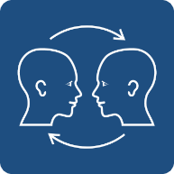

## “Nothing for us without us”

As we strive to create a more inclusive industry we must remember the mantra of the disabled community, “nothing for us without us”. This should be front of mind for all communicators when conceiving and executing campaigns, deploying brand ambassadors (e.g., actors, models, spokespeople, influencers), constructing their own teams, and more.

It enables organisations to leverage individual lived experiences and better identify disability and inclusion gaps and opportunities as well as ensuring content is accessible for individuals of all abilities.

## Meet Hannah Diviney

Paving the way for better disability representation is Hannah Diviney, a disability advocate and writer from Australia whose 2021 [Change.org petition](https://www.change.org/p/disneystudios-create-a-disney-princess-with-disabilities) asked Disney to add a disabled princess to its library of characters. Hannah’s petition aimed to “give millions of children around the world the invaluable chance to see themselves as the hero of their own story.”

It quickly gained supporters including Hollywood actor Reese Witherspoon.

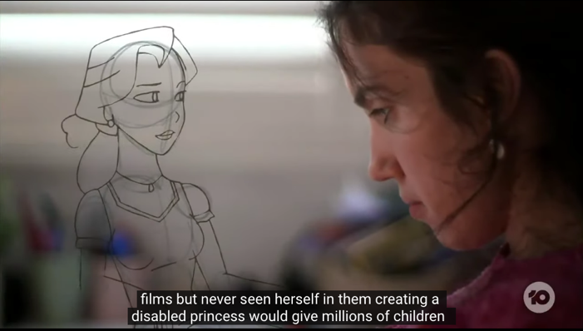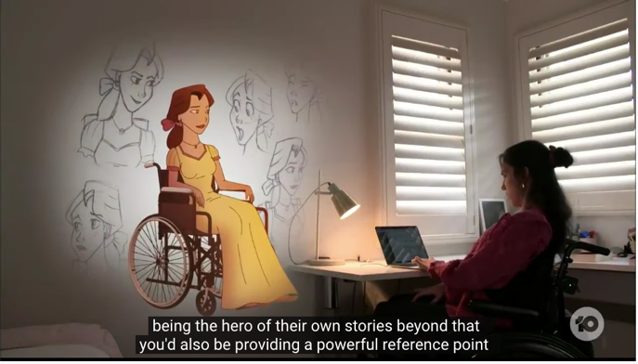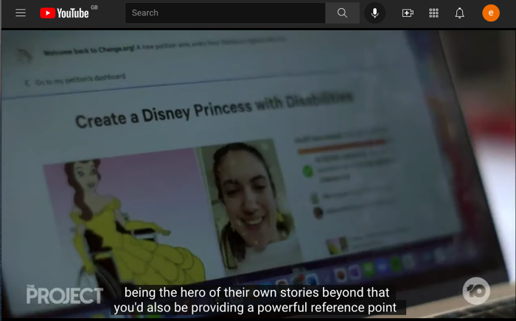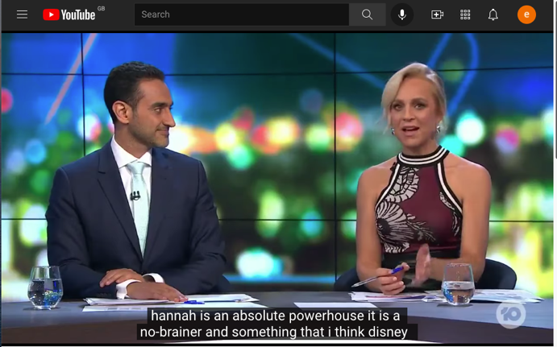

## UNDERSTANDING THE LIVED EXPERIENCE OF CONSUMING MEDIA AND CONTENT

A 2021 study of more than 800 people with disabilities in the US and UK explored their lived experience with media and content. Commissioned by Current Global, the research revealed that the majority struggles with accessibility. Even those who have access to and use assistive technology encounter significant problems. Looking at social media specifically, people of all disabilities (visual 22%, hearing 17%, speech 27% and cognitive 23%) reported a struggle with accessing the content.

For many, they have ‘normalised’ their consistently poor experiences, leading to low expectations of brands and the content they produce. Emotionally, this takes a toll.

But when content and communications are accessible, the response is overwhelmingly positive, leading to a significant rise in brand preference, purchase intent and peer recommendations.

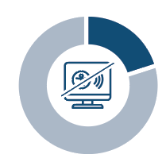

**A fifth of people surveyed said that social media platforms are very difficult to access and consume content on, making it the most problematic media channel.**

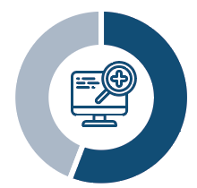

**56% of the overall audience need assistive tools, but they don’t have access to them, with many saying they are too expensive or inconvenient to set up.**

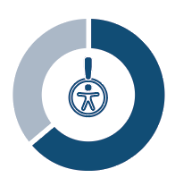**64% of those that use an assistive tool have reported having problems consuming content, with 30% of those respondents saying they have problems because of the content itself – pointing directly to where brands have an opportunity to help.**



**Inaccessible communications lead to a range of emotions:**

* **38% feel frustrated.**
* **31% feel disappointed.**
* **27% feel ignored.**
* **21% feel unhappy.**
* **17% feel isolated.**



**An overwhelming 81% have negative emotions towards brands when communications are not accessible, with feelings of being disconnected, less excited, or that the brand lacks positive qualities or is unreliable.**



**When brands are accessible, they reap a host of benefits and spark positive emotions including feelings of:**

* **satisfaction (49%)**
* **support (45%)**
* **happiness (41%)**
* **inclusion (36%)**
* **relieved (28%)**

# SECTION 2 – HOW COMMUNICATORS CAN MAKE A DIFFERENCE

## DISABILITIES AND THE IMPLICATIONS FOR ACCESSIBLE COMMUNICATIONS

Disabilities come in many forms, both visible and unseen, and fall within three broad categories:

* People with permanent disabilities.
* People with temporary impairments, e.g., broken arm.
* People managing situational requirements, e.g., working hands-free and eyes-free while driving.

We believe producing accessible communications within our industry should focus on people with permanent disabilities, which means working to the highest accessibility standards – that also encompass the needs of those with temporary impairments and situational requirements. The chart below shows the types of permanent disabilities and how they are most often manifested.

|  |  |  |
| --- | --- | --- |
| Image of an icon showing an eye - VISUAL  COLOUR BLIND LOW VISION BLIND | Image of an icon showing an ear - HEARING  HARD OF HEARING DEAF | Image showing the icon of a person using a wheelchair - MOBILITY  ARTHRITIS QUADRIPLEGIA SPINAL CORD INJURY |
| Image of an icon showing a brain COGNITIVE  LEARNING DISABILITIES AUTISM SEIZURE | Image of an icon showing a mouth speaking.   SPEECH SPEECH IMPEDIMENT UNABLE TO SPEAK | Image showing an icon of connections inside a head - NEURAL  BIPOLAR ANXIETY PTSD OCD – Obsessive compulsive disorder  DEPRESSION |

The disabilities that are most directly connected to and impacted by the accessibility of communications content and campaigns are the four highlighted: **Visual**, **Hearing**, **Cognitive**, and **Speech**.

Consideration should be given to hidden cognitive disabilities and neurodivergences such as dyslexia, ADHD, and autism that have an impact on how content is consumed. Texthelp offers up many useful resources such as these listed below:

* [Resources: Neurodiversity in the workplace](https://www.texthelp.com/resources/neurodiversity/)
* [Blog: 12 neurodiversity strengths that come from thinking differently](https://www.texthelp.com/resources/blog/12-neurodiversity-strengths-that-come-from-thinking-differently/)
* [Video Series: Supporting Neurodiversity at Work](https://mautic.texthelp.com/supporting-neurodiversity-in-the-workplace)

Mobility and Neural disabilities fall within the sphere of permanent disabilities too; however, they do not pose the same kind of consideration with regards to accessibility and consumption of the typical communications output our industry produces daily.

By ensuring that everything developed, curated or published within the remit of a communications campaign is made more accessible to people with visual, hearing, cognitive and speech disabilities, we will create more inclusive work that engages the widest possible audiences.

## WHAT THESE GUIDELINES COVER

We believe that communications content should be designed from concept to delivery to be inclusive of people of all abilities. For the purposes of these guidelines, we’ve defined ‘communications’ along the spectrum of services most commonly delivered by PR agencies and the work undertaken by in-house teams across earned, owned and social channels.

We do not cover the use of content generation tools such as ChatGPT. Many of these tools will generate accessible communications, but only if they are specifically told to do so. If you are using these tools, it is important that you understand the commands to use to ensure that the content generated is accessible.

We have not explored related services such as website or app development.

The World Wide Web Consortium (W3C) develops international Web standards for HTML, CSS, and more which web developers will be familiar with.

Compliance is key and it is the law in many countries for websites and digital channels to be compliant with the Worldwide Web Consortium Accessibility Guidelines, often referred to as WCAG AA (Worldwide Web Consortium Accessibility Guidelines) 2.1.

The publication of WCAG 2.2 is expected by the end of 2023, and will add several new success criteria focused on extending requirements for users with low vision, cognitive impairments, and limited fine motor skills.

All W3C standards are reviewed for accessibility support by the Accessible Platform Architectures (APA) Working Group. To find out more about accessibility implications in this context, please visit [the Worldwide Web Consortium (W3C) website](https://www.w3.org/WAI/standards-guidelines/).

Similarly, we do not address other areas of accessibility that may be important to a firm’s or client’s business such as accessible product design, which falls outside the typical remit of the communications function.

For additional guidance on handling practical issues associated with disability, please refer to the [“Accommodating Disability” section of the PRCA Diversity and Inclusion guidelines](https://www.prca.org.uk/sites/default/files/PRCA%20Diversity%20and%20Inclusion%20Guidelines%20-%20Web.pdf).

# SECTION 3 – DEVELOPING ACCESSIBLE CONTENT AND CAMPAIGNS

## TYPES OF CONTENT

In our guidelines, we have focused on the most common types of communications content, and the following pages set out the tools to use and the steps you should follow to apply best practice and ensure the greatest degree of accessibility. Types of content we will address include:

* Images
* Logos and brand identity
* Video and animated graphics
* Text and written copy
* Social media content
* Influencer content
* Events

We’ve also included a special note on PDFs (typically a challenging document format with regards to accessibility).

**Remember: These guidelines apply as much to the content you are paid to produce for your clients (as an agency) or your company (as an in-house team) as it does to the collateral you produce internally, such as branding, employee comms and web content.**

## VISUAL CONTENT

### IMAGES

In this section, we’re focusing on images used to illustrate an idea or convey meaning on web pages, within social media posts, etc.

#### ALT TEXT

All photography and images require alternative text (Alt Text) to make them accessible to individuals who are blind and partially sighted.

Alt Text is a textual description of a photograph, image, or other visual (e.g., charts or graphs) to help people who cannot see understand what is important.

Content creators write the Alt Text description for photography or images they use, then people who are blind or partially sighted use screen reading software to render Alt Text into speech and/or Braille output, which enables them to interact with the visual content.

To find photography and images within your content created through the Microsoft suite of programs – and to check that they have Alt Text added – use [Microsoft’s Accessibility Checker tool](https://support.microsoft.com/en-us/office/improve-accessibility-with-the-accessibility-checker-a16f6de0-2f39-4a2b-8bd8-5ad801426c7f#picktab=windows), which will direct you to any image without alt text and give you the option to add (or amend) Alt Text.

#### HOW TO ADD ALT TEXT

* Add your Alt Text description, ensuring that it is accurate, descriptive, and succinct. Focus on describing the most important message that an image is trying to convey.
* Autogenerated Alt Text is notoriously inaccurate, so review it and replace with your own Alt Text description if that makes the image description clearer. For example, an autogenerated Alt Text description of a person’s graduation photo might say, “a person standing outside, hat and trees” – correctly identifying the objects in the image but failing to recognise the connection between them or the context.
* Remember that screenshots, infographics, and charts are also images and should be treated in the same way as all other images with the use of Alt Text.

***Good Alt Text example:*** Cartoon illustration of a diverse team meeting in a boardroom. Colleagues are seated around a table. Four are visible, but the fifth is only outlined to show the team is missing a core member.

***Bad Alt Text example:*** A team meeting in an office.

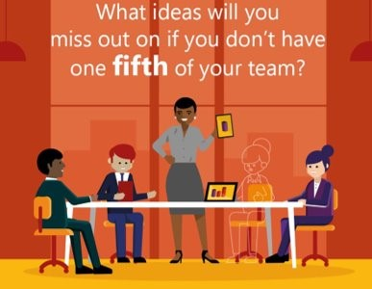

***Good Alt Text example:*** Photograph of a young Black woman smiling and waving at someone on her mobile phone screen. She has headphones on and is sat on a green chair.

***Bad Alt Text example:*** A picture of a woman.

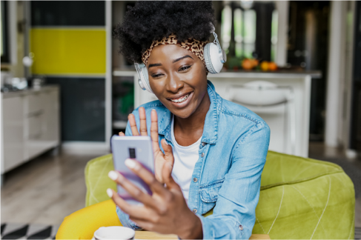

* When giving Alt Text to a colour choice (for example for items being ordered in a catalogue or on a website), give colour choices unambiguous, descriptive names and as much information as possible to help selection by people with visual impairment and colour blindness. It is good practice to provide names of colours and a short description of each as they relate to basic colours. For example, Ivory would be described as a shade of white with a silver hue. This is especially important when there are subtle colour differences. Please refer to the image that follows to see how this might work in practice.

***Good Alt Text for a colour choice  
(taken from catalogue of fabric swatches)*:**

An image displaying 10 different made-to-order fabrics. The first fabric is Oatmeal and is made of performance everyday linen, a medium weave providing slight texture. This fabric is a light brown with hints of white. The next fabric is Ivory and is made of performance everyday linen, a medium weave providing slight texture. This color is a shade of white with a silver hue. The third fabric is Oatmeal and is made of performance boucle, a looser weave providing higher texture. This fabric is a light brown with hints of white. At the bottom of the image, it also states that you may order free fabric swatches that will arrive in 3-7 business days

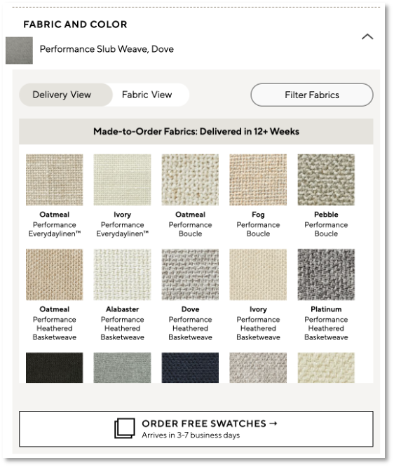

#### BEST PRACTICE FOR IMAGE USE

* Avoid use of colour alone to convey important information in an image.
* Avoid using important images as a background, such as placing them behind text or other design elements. Doing so may mean that the images are not picked up or adequately described by screen readers or other assistive technology used by people with visual impairments.
* Ensure strong contrast between text and background on an image. This improves readability for everyone, especially those with low vision and colour blindness. Dark text on a white or off-white background, or white text on a dark background provides the highest colour contrast.
* Do not use non-disabled actors and models to portray disability as substitutes for people with disabilities. It misrepresents the disabled community while taking away job opportunities for this underemployed community.
* If you are not organising a shoot of your own, [Getty Images’ Disability Collection](https://www.gettyimages.co.uk/sets/fglbSiRI4EGEhIpe9LgTlA/the-disability-collection) offers good stock images of people with disabilities to use within your content. Other helpful resources include, [Unsplash](https://unsplash.com/s/photos/people-with-disability), [SocietyPix](https://societypix.org/), [Pexels](https://www.pexels.com/search/people%20with%20disabilities/), [Stocksy](https://www.stocksy.com/search/people%20with%20disabilities?text=people+with+disabilities&page=1&sort=relevance), [TONL](https://tonl.co/), and [Disabled And Here](https://affecttheverb.com/disabledandhere/).
* Use images depicting individuals with real disabilities interacting with products, services and other people to confirm the reality that people with disabilities are individuals with capabilities, agency and intersectional identities. Having a disability is only one of the many parts that defines who a person is.
* Steer clear of “inspiration porn”: content that features people with disabilities to inspire people without disabilities. It objectifies people with disabilities for the benefit of people without disabilities. These depictions can sometimes be patronising, frame people with disabilities as objects of pity, or individuals who overcame their disabilities.
* When depicting people who use wheelchairs, demonstrate wheelchairs as tools of liberation rather than chains of confinement. This action will align our content with the Social Model of Disability which recognises that people with disabilities are not disabled by their disabilities but by the inaccessible society in which they live.

### LOGOS AND BRAND IDENTITY

The accessibility of logos and brand identity is an in-depth topic and could warrant an entire set of guidelines for design professionals.

For the purposes of this document however, colour contrast is perhaps the most important consideration for communications professionals when we think about branding. Page 42 includes instructions of how to use Microsoft’s Color Contrast Analyzer tool.

**CASE STUDY: Refreshing Brand Colours and Logo of Current Global**

In its pursuit to champion accessibility, Current Global recognised it needed to improve the accessibility of its own brand colours and logo. Two of its four colours were deemed to lack sufficient contrast for people with low vision and colour blindness. These colours, a bright yellow and bright green, were sometimes challenging to see on a white background.

Subsequently, the agency embraced this opportunity. Using the Web Aim Colour Contrast Analyzer to adjust brand colours to meet colour contrast accessibility requirements, the design team replaced the bright green with a soft purple; and a refreshed logo and branding now reflects these changes. [Visit Current Global’s website](https://www.currentglobal.com/) to learn more about their commitment to accessibility.

**BEFORE:**

The image shows the Current Global Logo before the re-design. It features the name Current Global, with a graphic to the left of the name showing four small arrows all pointing inwards. However, the blue, green, red and yellow are not sufficient in meeting the required standard. 

**AFTER:**

The image shows the Current Global Logo after the re-design. It features the name Current Global, with a graphic to the left of the name showing four small arrows all pointing inwards. The colours of purple, green, red and orange now meet the required standard. 

Current Global logo with hyperlink to www.currentglobal.com

### VIDEO AND ANIMATED GRAPHICS

**Transcripts** are supplemental documents that include text for the audio and visual components of your video. Created in various formats, transcripts can resemble a screen play (including speaker dialogue, background sounds and stage directions). Transcripts are necessary for podcasts and other audio materials.

Adding a transcript enables the inclusion of people who are deaf-blind, deaf, hard of hearing, and/or neurodiverse. Additionally, it benefits people who prefer reading text over watching a video or listening to audio.

#### HOW TO CREATE TRANSCRIPTS FOR VIDEO

Creating a transcript involves manually transcribing in sequence what you see and hear. Pretend you are writing a screen play while you document the dialogue, sounds, and actions within the video.

To create a readable video transcript, you can create a SubRip Text file (SRT), which is a common file format for subtitles and captions. Alternatively, search for tools that will automatically generate transcripts accurately.

For instructions, [use 3Play Media’s SRT File Guide](https://www.3playmedia.com/blog/create-srt-file/).

**Closed captions** are on-screen displays of text for audio within video content, which enable individuals who are deaf, hard of hearing, or neurodiverse to consume content. Closed captions also help non-disabled people consume content in a noisy environment.

This accessibility feature can be turned on and off. When activated, it provides an on-screen textual transcription of dialogue and other sounds synchronised with the video and audio.

#### HOW TO ADD CLOSED CAPTIONS TO VIDEO

Select an editing software to add captions to your video. The process will vary based on the platform. Some will require the creation of a transcript as a SubRip Text File (SRT file,) others will provide auto-generated captions. When using auto-generated captions, always review the captions and make edits to ensure completeness and accuracy. When creating an SRT file, follow the [3Play instructions hyperlinked in the transcripts section](https://www.3playmedia.com/blog/create-srt-file/), transcribing dialogue and sounds as well as providing time stamps.

For videos within social media posts, instructions are available on the given platform’s accessibility page.

An **audio description** is a secondary audio track for videos, with verbal narration for audiences with low or no vision. This accessibility feature helps people imagine what is happening on screen and allows other viewers to multitask while consuming the content. Audio description also provides narration of important visual elements during periods of silence and gaps in dialogue. For an example of a well-crafted audio description, check out [Current Global’s Accessible by Design Video](https://vimeo.com/538108493/fe03fd9c36).

#### HOW TO ADD AN AUDIO DESCRIPTION TO VIDEO

Integrating audio description from the start results in more accessible videos from the get-go, but you can improve the accessibility of videos you already have by adding audio description at a later stage. Regardless of which approach you take, here are some tips:

* **Start with your goal.** Your video was conceived to persuade someone to think, feel, or do something. Identify which visuals help convey your argument and objectively provide audio description for these visual elements.
* **Focus on storytelling.** Recognise the story your video was intended to tell and what visuals communicate this story. Include descriptions for these visual elements.
* **Use the present tense in an active voice** while providing third-person narration. For example, Tim arrives home and unlocks his door. Use complete sentences when possible.
* **Consider tone.** Determine the desired tone of your video. Incorporate this tone when choosing the words to describe your visual elements and selecting the voice to record your audio description track.
* **Strategically insert descriptions.** Review the screen play for your video and plan pauses in the dialogue to insert your audio description. Describe actions, objects, and people while or slightly before they appear on screen. Avoid recording your description over dialogue unless reading subtitles.
* **After recording** your audio description and integrating it within your video, listen to it with your eyes closed to assess whether you missed anything. You can also make changes postproduction.

#### FOR ALL VIDEOS AND ANIMATED GRAPHICS, YOU SHOULD:

* Always include a transcript, closed captions and audio descriptions.
* Provide the option of switching captions on or off while watching a video.
* Ensure strong contrast between text and background. It enables people with low vision and colour blindness to see and use your content. For the highest contrast, use white text on a black background or black text on a white background.
* Enable the Stop/Pause feature when a video plays automatically for more than 5 seconds.
* Avoid graphics shifting significantly and at different rates than text or other elements.
* Do not use flashing lights: this could trigger a seizure among individuals with epilepsy.
* Host content in an accessible player that supports accessibility features like closed captions, audio-description, various contrast themes, etc. Recommended accessible players include Able Player, Vimeo and ONE player.
* Allow users to adjust the play back speed of your content. Allow them to increase and decrease the playback speed. This will support neurodivergent people and others’ listening preferences.
* As per the earlier advice regarding Best Practice for Image Use, do not use non-disabled actors and models portraying disability as substitutes for people with disabilities.

**CASE STUDY: Kingsford “Preserve the Pit” Campaign**

Closed captioning placed on video content produced for Kingsford “Preserve the Pit.”

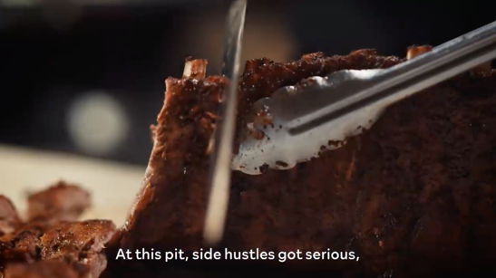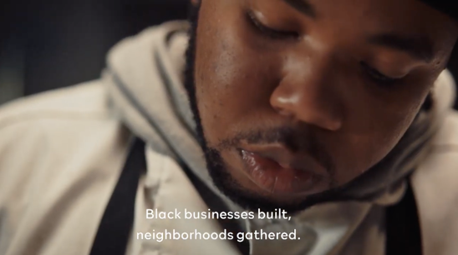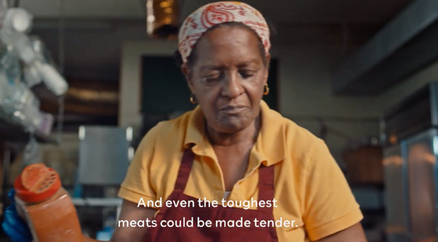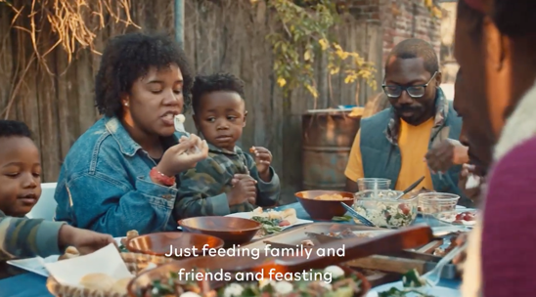

## TEXT AND WRITTEN COPY

It might surprise you to learn that the average American reads at the 7th to 8th-grade level (or aged 12-14), and that 20 percent of the population reads at below a fifth-grade level. [67 million people in the US speak English as a second language](https://www.census.gov/newsroom/releases/archives/miscellaneous/cb12-134.html). Of those, 13 million speak English ‘not well’ or ‘not at all’. In the UK, as many as [7 million people have ‘very poor literacy skills’](https://literacytrust.org.uk/information/what-is-literacy/). [Average reading age in the UK is 9 years old: *The Guardian* has a reading age of 14. *The Sun* a reading age of 8](https://www.ascento.co.uk/blog/are-you-aware-of-how-literate-your-employees-are#:~:text=Readability%20data%20suggest%20that%20the,a%20reading%20age%20of%208.). It is important to understand therefore that the accessibility message should also encompass readability. A website or any piece of digital content should be technically accessible but if the language is complex the message may be misunderstood. To ensure the broadest accessibility across the cognitive spectrum, simplicity is paramount.

These two articles from Texthelp provide useful advice about readability: [Best practice advice: what is readability](https://www.texthelp.com/resources/digital-accessibility-guide/what-is-readability/) and [Blog: 8 writing tips for improving readability of blog post content](https://www.texthelp.com/resources/blog/8-writing-tips-for-improving-readability-of-blog-post/).

#### FOR ALL TEXT AND WRITTEN COPY, YOU SHOULD:

* Wherever possible use at least size 12 font.
* Wherever possible use a San Serif font such as Arial or Verdana to make your content easier to read for individuals with print-related disabilities, including low vision and Dyslexia.
* Wherever possible, consider using [Dyslexie font](https://www.dyslexiefont.com/), which improves readability for people with Dyslexia.
* Write for people in late junior school/early secondary school (7th grade in the US): age 9-15 is best practice.
* Write concisely in plain language and the active voice.
* Use headings and spacing to group related content.
* Avoid the use of abbreviations and jargon.
* Use high colour contrast text.
* Avoid more than two lines of centred text.
* Avoid more than one line of italics.
* Consider creating an audio version of any article, blog post, and news release to help those with blindness, low vision, and Dyslexia. Enable users to adjust the playback speed.
* Always use meaningful display names for hyperlinks, which help people who use screen readers, keyboard navigation and voice recognition software by clearly and concisely communicating the function and purpose of a link when read out of context. When selecting hyperlink display names, choose specific short and easy to say names, which indicate where the link will take someone as is demonstrated throughout this document. To avoid confusion, do not duplicate display names or use ambiguous names such as “Click Here” and “Read More”.
* Use appropriate disability-inclusive language which affirms the human dignity of people with disabilities; the [National Centre for Disability in Journalism](https://ncdj.org/resources/writing-and-editing/) provides [guidelines for writing positively about people with disabilities.](https://adata.org/factsheet/ADANN-writing)
* **Be thoughtful**. Use people-first language when referencing someone with a disability, e.g., “a person who is hard of hearing” or “an individual who uses a wheelchair” rather than “a hard of hearing person” or “a wheelchair user.” However, use ability-first language if the individual or sub-group of the disabled community prefers (e.g., “the autistic community”). For further guidance, use this [Disability Language Style Guide](https://ncdj.org/style-guide/).
* Eliminate ableist language from your writing. It dehumanises and stigmatises the disabled community and is a form of discrimination and social prejudice. Example language includes “dumb”, “stupid”, “lame”, “crazy”, and “insane”: words that fail to clearly and effectively articulate negative feelings towards someone or something while harming the disabled community.
* Avoid using words that describe disability and the disabled community such as “blind”, “deaf” etc. as part of figurative language to convey negative meaning. For example, blind is sometimes used to describe individuals who are unaware or ignorant: *The blind leading the blind produces problems*. More direct language should be used instead for a clearer meaning: *When ignorant people lead others who are also poorly informed, it produces problems.*

#### Organise Documents with Headings

When you add headings to a document, you improve the navigation experience for people who use a screen reader because headings communicate how the content in a document has been organised.

It also supports individuals who are neurodiverse and/or those with learning differences, as headings enable them to easily find essential information and anticipate what else to expect in the document.

When creating headings, ensure headings are at least two points larger than body text to make it easier for individuals to differentiate between the two.

You may need to review your corporate identity guidelines to ensure that they reflect this guidance.

**A word about literacy**

Literacy refers to a person’s ability to use printed or written materials to function in society, achieve their goals, obtain knowledge, and develop their full potential.

Health literacy is vital to making informed decisions for yourself and your family.

Digital literacy impacts your ability to use innovative technologies to improve your work and personal life.

Financial literacy impacts your economic well-being and that of your family, potentially for years to come.

Literacy extends to numeracy – the ability to understand and work with numbers.

Mathematical equations within an image unknowingly deny access to people with Dyslexia and/or low vision, who rely on an optical character recognition (OCR) software, a screen reader, and/or Braille. To remedy this, use the computer programming language [Mathematical Markup Language (Math ML),](https://www.w3.org/TR/mathml4/#:~:text=MathML%20is%20a%20markup%20language,enabled%20this%20functionality%20for%20text.) which maintains the format of mathematical expressions and enables people to consume content with adaptive technology.

#### PDFs

Microsoft’s Accessibility Checker (check page 40) is a great tool for flagging accessibility issues that need addressing throughout the Microsoft Office suite. PDFs, however, can cause issues for people with visual impairment as screen readers can’t access the format, and the Accessibility Checker can’t be run over a PDF either.

If it is necessary to produce a document in PDF format, publish a companion version in another format as well, such as Word.

These short [PDF training videos from Microsoft on YouTube](https://www.youtube.com/playlist?list=PLtSVUgxIo6KrxMh-wNhSG7MuZ2gfPf7co) share the steps to making PDFs accessible; the [University of Washington’s website](https://www.washington.edu/accessibility/documents/) also offers an extensive guide on creating accessible PDF documents.

#### EMAIL

Writing accessible emails is critical for our profession. Through emails, we consult and collaborate with clients and colleagues, and coordinate media outreach. If our emails are not accessible, we risk not being received or understood by all our intended recipients.

* An accessible email takes format, font, and signature into consideration.
* HTML is the most accessible format for screen readers because it enables headings and Alt Text. Ideally, use a San-serif font (such as Arial or Verdana, which are pre-installed on all operating system platforms). Use a font size that is at least 12 points in size to improve readability for recipients who are neurodiverse or visually impaired.
* An accessible signature allows users of screen readers to access contact information.
* Always remember to add Alt Text for any visuals you include in emails.

## SOCIAL MEDIA CONTENT

Each social media platform has its own guidelines and standards for accessibility and inclusivity. Here we cover the basics for each. There are, however, some general dos and don’ts when it comes to making social media posts accessible that are relevant regardless of the platform

* **DO** add or edit Alt Text for your images; check each platform for options/best practices.
* **DO** caption videos; check each platform for options/best practices.
* When including a hyperlink, **DO** indicate whether it leads to an audio, image, video, etc.
* **DO** use a URL shortener to minimise the number of characters in the hyperlink.
* **DO** use CamelCase Hashtags and place them at the end of a post. Create a CamelCase hashtag by capitalising the first letter of each of the words. An example is #AccessibleCommunication.
* **DO NOT** accept the machine-generated Alt Text without checking to see if you can provide more context for screen reader users.
* **DO NOT** use acronyms in posts unless you have previously clarified the unabbreviated name followed by the acronym in parentheses within your post.

Bear in mind that social media platforms impose character limitations, which may prevent you from creating Alt Text with adequate detail. Additionally, some platforms do not allow you to add Alt Text for posts with multiple images. In these situations, add your Alt Text in the body text of your post.

Also, social media platforms do not allow you to add audio description to videos within your post. To make your post accessible to a person who is blind or partially sighted, include a summary of your video within the body text of your post/article.

### **FACEBOOK**

The top things to know when making your posts and content accessible for Facebook:

* You can add captions to a video to make it accessible to a broader audience using the SubRip Text (.srt) file format.
* If you choose to upload a .srt file, make sure your caption files are correctly named and formatted before you upload them.
* To add captions to an existing video on your Page, find the post on your Page’s timeline, click the top-right corner, select Edit Post and follow the steps.   
  *Note*: People who watch your Page’s video with sound turned OFF will automatically see captions. People who watch your video with sound turned ON will need to turn on captions to see them. The language captions appear in is determined by a user’s selected preferred language.
* Click on [Facebook’s accessibility page](https://www.facebook.com/help/accessibility) to learn more on how to make a post accessible on Facebook.

### **INSTAGRAM**

Top tips for making your posts and content accessible for Instagram:

* Automatic Alt Text is rarely effective; it is generally better to replace with your own description that provides more context for an image description.
* Automatic Alt Text uses object recognition technology to provide a visual description of photos for people with visual impairments. Users can hear descriptions of photos through a screen reader within Feed, Explore and Profile pages.
* Try to avoid Instagram Stories for important information.
* Add captions in Instagram Stories with enough information so the person doesn’t have to rely on audio.
* To avoid confusion, do not use emojis to replace words. Add any emojis to the end of your copy and limit use to three or less as screen readers read the title of each emoji.

Visit [Instagram’s accessibility page](https://about.instagram.com/blog/announcements/improved-accessibility-through-alternative-text-support) to learn how they are supporting accessible content.

The following images show how easy it is to add Alt Text within Instagram.

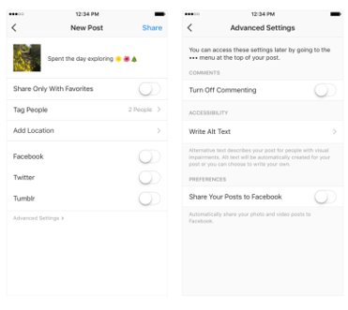

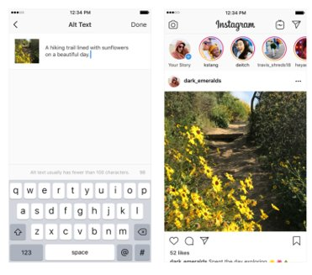

### **LINKEDIN**

The top things to know when making your posts and content accessible for LinkedIn:

* Add descriptive Alt Text to images in LinkedIn. Bear in mind however that Alt Text can only be created when crafting content on a computer, **not on a mobile device**.
* LinkedIn only allows Alt Text for posts with one image and limits Alt Text to 300 characters. The best practice is therefore to optimise LinkedIn posts by using only one image.
* Make sure captions on any videos you include are burned into LinkedIn native video, [visit Hootsuite](https://blog.hootsuite.com/linkedin-video/) for more information.

Click on [LinkedIn’s accessibility page](https://www.linkedin.com/accessibility) to learn more on how to make a post accessible on LinkedIn.

### **TIKTOK**

The top things to know when making your posts and content accessible for TikTok:

* TikTok supports automatic text-to-speech conversion with its “Text-to-speech” feature. When editing, select the text you would like to convert and select the “Text-to-speech” option.
* TikTok also supports automatic captioning. You can add captioning during video editing, or when the video is uploaded. Text is automatically transcribed and can be edited before it is displayed on your video.

Visit [Tik Tok’s accessibility page](https://www.tiktok.com/accessibility) to learn about other features to make posts accessible.

### **TWITTER**

The top things to know when making your posts and content accessible for Twitter:

* When you Tweet photos using the Twitter app for iOS or Android, or on twitter.com, you have the option to add Alt Text so that content is accessible to more people, including those who are blind or have low vision.
* Twitter supports Alt Text badges (showing that an image has Alt Text) and exposed image descriptions (meaning anyone can view and read Alt Text for an image).
* Be sure to turn on Alt Text for images within your Twitter settings.
* Limit emojis as screen readers read the title of each emoji.
* Twitter has launched a feature that automatically adds captions to video.

Visit [Twitter’s accessibility page](https://help.twitter.com/en/using-twitter/picture-descriptions) which has easy-to-follow instructions on how to add image descriptions, how to add voice-over, and how to access and use screen readers for people with vision impairment.

The following images show how easy it is to make posts accessible on Twitter.

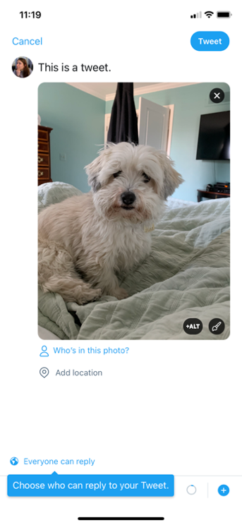 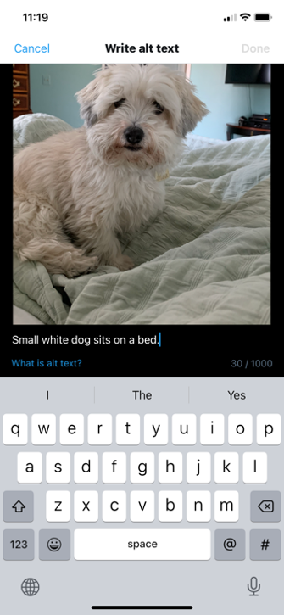

**CASE STUDY: Shamrock Farms**Within weeks of committing to accessible communications, Current Global started employing best practices across client activations including:   
  
***Adding Alt Text into social content made for its client Shamrock Farms.***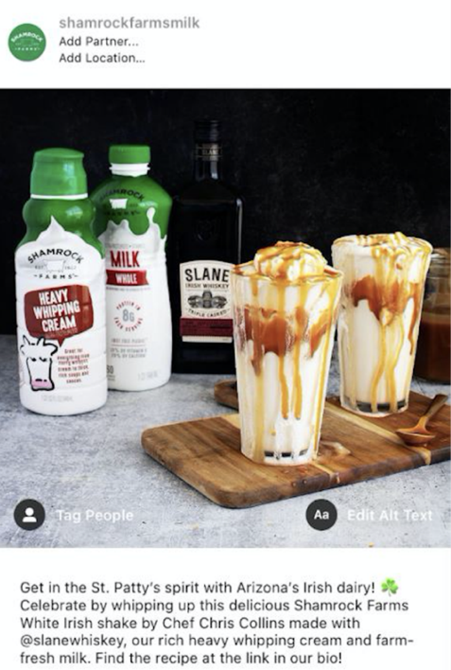 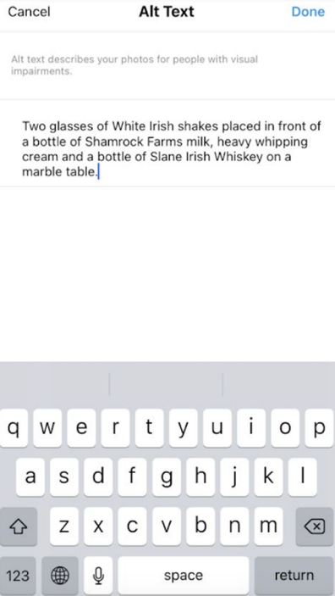

## INFLUENCER CONTENT

As agency teams are not the only ones creating content for clients, we should be sharing – and encouraging – the same use of guidelines and digital tools with influencers, asking them to be a part of the effort to make communications accessible to all.

Steps to employ:

* Include an ask to do their best to make communications accessible in briefs.
* Share these guidelines or other internal checklists along with the brief.
* Underline the ask and discuss any challenges during content production.
* Consider collaborating with influencers to add accessibility features like closed captions, audio description and transcripts to all projects.
* Work with internal teams to ensure people with disabilities are appropriately represented in partner recommendations.
* When selecting influencers, look to hire disabled creators. Through lived experience they are likely to be in a better position to authentically communicate to the disabled community how a product or service affects them.

## PHYSICAL AND VIRTUAL EVENTS

Delivering events is commonplace in our industry – from town hall meetings for internal audiences to press briefings, trade shows, and large-scale gatherings for external audiences. While many venues and event planners are aware of making events accessible for attendees with mobility disabilities, there are several factors that should be considered to ensure your event’s communication meets the needs of everyone, whether in-person or virtual.

These guidelines do not address accessibility considerations for the built environment, however.

Here are a few general guidelines to keep front of mind when planning events:

* When inviting or confirming attendees or delegates, use an RSVP form to understand and accommodate differing needs.
* Communicate to attendees prior to the event about any lighting, use of fog machines or sounds that may be an issue.
* Provide a quiet space to enable the retreat of people who are adversely impacted by over-stimulating sounds and lights, such as those with autism or who are prone to migraines or seizures.
* Provide regular and frequent breaks. It will help prevent cognitive overload, support people who can’t sit for long periods and those who may need frequent bathroom breaks.
* Include helpful accessibility information on the programme, homepage and running order as a footer on your live events.
* Add closed-captions and audio descriptions to video presentations.
* Verbally describe images and narrate tutorials during a presentation as if you are speaking on a podcast to include individuals who are blind and partially sighted.
* [View this verbally narrated example](https://vimeo.com/596622100) on how to check the colour contrast of your slides in PowerPoint.
* Consider hiring a sign language interpreter for people with hearing impairments, a resource that can be helpful for both presentations and conversations between attendees. According to the [Rhode Island Commission on the Deaf and Hard of Hearing](http://www.cdhh.ri.gov/information-referral/american-sign-language.php) “Over half a million people throughout the United States use American Sign Language (ASL) as their native language,” and “ASL is the third most used language in the United States after English and Spanish.”  
  The disability-advocacy non-profit organization Disability:In uses ASL services from [Purple Communications](https://www.signlanguage.com/) at the time of the publication of these guidelines.
* Ensure speaker notes are reviewed for simple language and to catch acronyms or visuals that contain key information but don’t have written or verbal descriptions.
* Provide recordings and digital transcripts of all presentations in case audience members miss things in the live version. When providing transcripts, include headings and hyperlinks to enable screen reader navigation for individuals who are blind, partially sighted and deaf-blind. Remember, when providing recordings, allow users to adjust the play back speed.
* Provide accessible maps to help attendees navigate around the venue. Provide information about the location of bathrooms, quiet spaces, accessible seating, service animal relief areas, charging stations, etc.
* Consider fast-track queuing for people who cannot stand for long periods.
* Help attendees who need additional support navigating the event by creating a buddy system and/or offering a complimentary ticket for a companion.
* Instruct event staff how to assist guests who are blind and partially sighted with navigating the event by giving clear verbal directions and offering sighted guide assistance.
* Always ask a blind or partially sighted person if they would like assistance first and never grab or touch them without permission. [For detailed sighted guide instructions visit the Braille Institute’s website](https://www.brailleinstitute.org/wp-content/uploads/2018/05/Braille-Institute-Sighted-Guide-Techniques-to-Help-You-Help-Others.pdf).
* When providing sighted guide assistance, allow people who are blind and partially sighted to hold your arm while walking a half step in front of them and providing verbal directions.
* Provide paper and writing utensils for all attendees. This will assist individuals who have speech disabilities communicate questions and requests.
* Consider hosting hybrid events, so attendees can choose to attend in-person or remotely. This will help people bypass mobility and other challenges.

#### HOSTING A VIRTUAL EVENT (INCLUDING VIDEO CALLS AND WEBINARS)

Throughout the pandemic, video calls and webinars emerged as a critical tool for organisations communicating with internal and external stakeholders. Follow these steps to create an accessible and inclusive virtual event experience:

* Provide participants with instructions about how to access the virtual platform, including keyboard navigation directions for individuals who are keyboard users, blind, partially sighted and deaf-blind.
* Ask participants to turn on their camera when speaking to enable lip reading for individuals who are deaf or hard of hearing.
* Ask speakers to introduce themselves with self-descriptions. It is a verbal description of a speaker’s physical appearance and may include information such as a speaker’s name, pronouns, race or ethnicity, disability, distinguishing physical characteristics, clothing choice, and background. A self description improves inclusion for people who are blind, partially sighted, neurodivergent and/or joining with a low internet bandwidth. It helps these individuals mentally visualise speakers. [Here is a video example of a self-description](https://accessible-communications.com/take-the-21-day-challenge/day-1-practise-your-self-description/) from Current Global CEO Virginia Devlin.
* Ask participants and speakers to state their name each time they speak to indicate speaker changes to help people who are blind, partially sighted, and/or neurodivergent.
* When reviewing materials during the session, send accessible materials in advance to provide participants of all abilities the time and the opportunity to consume and process the information. When sharing your screen, describe key visual elements within your content to include individuals who are blind or partially sighted.

## HELPFUL TIPS AND TOOLS

Good news! Most of the tools we need to produce accessible communications are free and readily available.

Microsoft has a suite of tools within Office 365 that includes an embedded Accessibility Checker tool, and Microsoft Teams offers live captioning.

There is an abundance of how-to videos on YouTube to help make producing accessible content as straight forward as possible. Modern browsers all have the functionality to convert web text and images into speech. Every major social network has a range of accessibility tools. And the list goes on.

### MICROSOFT ACCESSIBILITY CHECKER

Within each of the Office 365 products (Outlook, Word, PowerPoint, etc.) there is an **Accessibility Checker**. When enabled, this tool reviews your document for any areas that may create an accessibility problem.

**HOW TO USE:**

* Under the **Review** tab in your toolbar, select **Check Accessibility** (on the left-hand side).
* Click on each identified issue that gets flagged and the tool will take you to that location for resolution.
* Issues might include Alt Text missing from images, poor colour contrast with text on a page, titles missing from slides, inconsistent text running order on in a PowerPoint, etc.
* “Errors” that get identified as such should be addressed as they will cause problems to those with sight or hearing impairment.
* “Warnings” however are potential issues rather than must-fix errors.

*Please note this is applicable across the suite of Microsoft tools:*

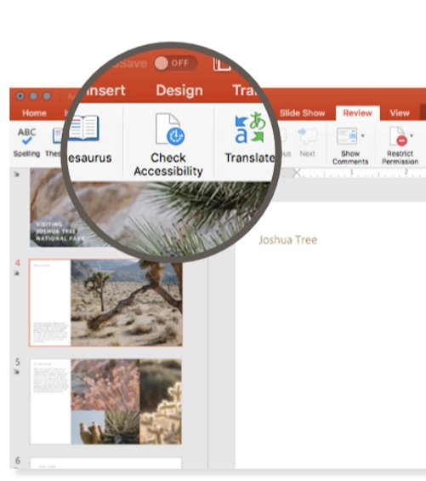

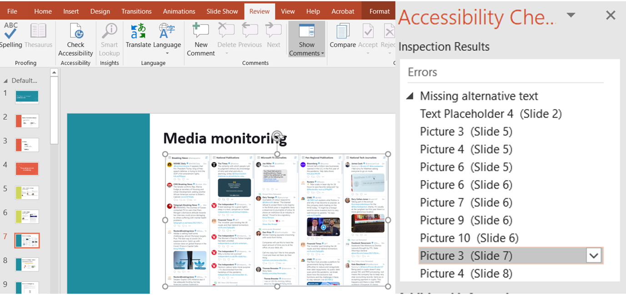

### MICROSOFT COLOR CONTRAST ANALYZER

People with low vision often have difficulty reading text. The problems can be exacerbated if they also have a colour vision deficiency such as colour blindness that lowers the perceived contrast even further. Ensuring adequate contrast makes it easier for everyone – not just the visually impaired - to read text content.

Microsoft’s Colour Contrast Analyzer is a feature in Accessibility Insights for Windows that helps developers and designers investigate contrast ratios. Colour contrast rules apply for video, motion graphics, graphics, and text overlay. Text smaller than 18-point font requires a colour contrast ratio of at least 4.5 to 1. However, Bold and large print, 18-point and greater requires a colour contrast ratio of at least 3 to 1.

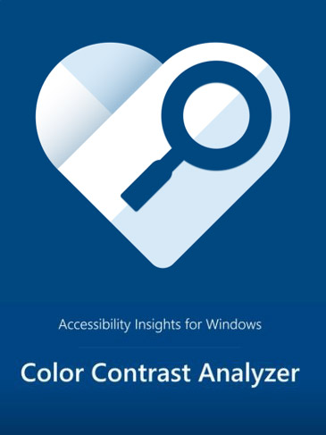

**HOW TO USE:**

* Visit [Accessibility Insights Colour Contrast](https://accessibilityinsights.io/docs/en/windows/getstarted/colorcontrast/) to get started with this tool.
* Download the app on your desktop.
* Watch this short [Accessibility Insights YouTube video](https://www.youtube.com/watch?v=eEAYRBG4TOE) to learn how to use the colour contrast analyser.
* Remember to check the Colour Contrast Analyzer throughout the production of your content.

### WINDOWS SCREEN READER

Windows 10 has a built-in, easy to use screen reader called Narrator for people who are blind and partially sighted.

Narrator enables people who are blind or have a visual impairment to navigate websites, apps and Word documents.

This [Microsoft Narrator YouTube video](https://www.youtube.com/watch?v=EiQ8NwdsZCY) gives very simple instructions for getting started with Narrator, keyboard shortcuts to use and how to navigate through different websites and applications.

Image of a diagram showing the steps to follow to turn on screen reader.

Step 1: Go to 'Settings'
Step 2: Go to Ease of Access
Step 3: Go to Narrator and click the slider marked Narrator to the 'On' position.
Or tap the Windows key and type: "Turn On Screen Reader"

**CASE STUDY: Microsoft “The Fifth” Campaign**

Current Global supported client Microsoft with an EMEA-wide campaign called “The Fifth,” which highlighted the business value of embracing accessibility. To reach European business decision makers, the team created fully accessible assets that drew attention to Microsoft’s built-in accessibility solutions. A series of visuals explored how businesses that are not embracing accessibility are 'missing a fifth' of their opportunity, as well as The Work life Hack series which highlighted tools and features useful for all workers, including those with disabilities. Images were amplified across social channels and directed people to other content in the series, including an interactive quiz which further reinforced the importance of accessibility in the workplace.

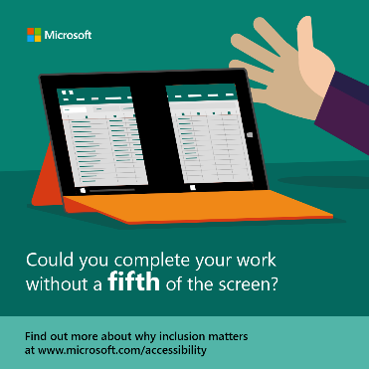 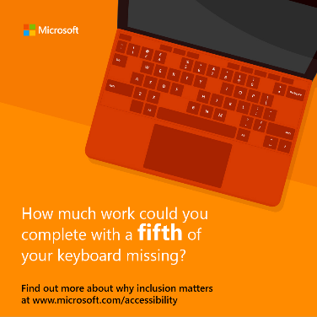

# SECTION 4 – EMBEDDING ACCESSIBILITY INTO YOUR COMMUNICATIONS FUNCTION

## BEST PRACTICE

While many tools to produce accessible content already exist, the key step-change really comes down to embedding accessibility standards and best practices in your overall approach to creating any kind of content. Clicking on the Accessibility Checker should become as routine as using spellcheck!

### What does best practice look like?

#### Publish a manifesto

Once you’ve decided to commit to making communications accessible, write a manifesto that outlines what you’re doing and why you believe it to be important. Share it with colleagues, display it around your office, include it in your credentials or company brochure, post it on your website.

Here’s an example from Current Global:

My father was deaf. So was his twin brother, my uncle. Growing up it was always a challenge to communicate with them. But as a family, we always made the effort.

That’s what you do.

Sadly, it’s not always been my experience in professional communications. Every day content is published that’s inaccessible to many, campaigns are launched that aren’t designed to be inclusive of people of all abilities. But it doesn’t have to be that way.

Over a billion people – one in eight of the world’s population – have some form of disability. With an ageing population, more than two billion will need at least one assistive communication, memory or hearing aid in the next 10 years. That’s a significant audience to exclude by default or by design.

We have a moral duty to change this, and it makes obvious commercial sense for our clients too. **So, we’re making a commitment as an agency.**

When we say we’ll develop campaigns that engage everyone, we mean it.

When we make interactive online content, it won’t just be for some, but for all.

When we build brands, we’ll make sure they can reach every single person.

On behalf of our clients, every piece of communication we develop, curate and publish will meet the highest accessibility standards.

We’ll work to build the in-house capabilities of our clients to do the same.

And we’ll partner with professional bodies around the world to champion accessibility and promote industry best practice.

Things won’t change overnight, but if we make the effort, we hope others follow.

As passionate communicators, it’s what we do that matters.

George Coleman  
Joint CEO, Current Global

#### Get your own house in order

Committing to accessible communications means that all external emails, documents, spreadsheets, presentations, visual content, websites etc. should be made accessible to all. This refers to the content and material you are producing internally as well as content for external audiences. Before you ask your firm or agency to make the commitment, make sure that your website has gone through all the necessary accessibility checks, and that credentials (capabilities decks) and templates that teams regularly use have been updated to meet the highest accessibility standards.

You might consider using digital business cards rather than traditional printed ones, as a format that’s more accessible to people with visual impairment. Current Global and digital business card platform [HiHello](https://www.hihello.me/) have been working together to make their offer as accessible as possible to people using screen readers, and is a useful alternative to Braille printed business cards.

Regarding websites, there are several plug-ins available that identify on-going changes required to meet Web Content Accessibility Guidelines (WCAG 2.0). Remember, it is the law in many countries for your websites and digital channels to be compliant. For more information, visit the [W3C Guideline webpage](https://www.w3.org/WAI/standards-guidelines/).

It is important to understand that plug-ins are helpful for identifying some accessibility issues, but it is not enough to ensure the full accessibility of your digital content. Plug-ins are generally not effective enough to ensure compliance with accessibility standards and usability for individuals with disabilities. The reality is that nothing beats investing time in continued manual testing of your digital content from an accessibility specialist.

Recognise that this is a continuous process, particularly to keep up with evolving accessibility standards and changing technologies.

#### Develop a communication plan

Let employees know what you’re committing to, why it matters and what your expectations of them are in delivering accessible communications. What internal communications channels can you use to spread the word? What training does your team need to understand the tools and requirements? Share regular reminders with staff to use the tools. Share case studies of work where it has been put into practice. Make accessibility training part of your on-boarding for all new employees.

Let clients or other stakeholders know what you are committing to, why it matters, how and when you plan to roll it out, any cost implications and what differences they are likely to see. For agencies, committing to accessible communications as part of your client service offer can often be accommodated within standard fee rates. Additional third-party costs can, of course, be flagged and passed on to clients.

#### Practice makes perfect

Get familiar with the tools included in these guidelines and start using them TODAY! At the start of every project, reference the checklist at the end of this document.

Cultivate a disability-inclusive culture for yourself and within your firm by adopting accessibility as a habit. Research shows it takes a minimum of 21 days to develop a habit. [Visit this link to start a 21-day challenge](https://accessible-communications.com/take-the-21-day-challenge/) to learn the fundamentals of accessible communications.

#### Plan ahead

Build in time to facilitate any extra steps required to make your content accessible. Involve creative, design and production teams early! Give them time to implement what’s required, whether that’s adding in closed captions for videos or reworking a previously used presentation to reflect the fact that the colour contrast needs to be improved.

## CHECKLIST

Use this checklist to help ensure that your work is accessible by design. Share it with all team members, talk it through at the kick-off stage, and keep referencing it until accessibility becomes a natural part of everything you produce.

**Project Kick Off**

* Have I thought about all content that needs to be made accessible?
* Do I know how to ensure each element is made accessible?
* Have I alerted my creative, design and/or production team about what’s needed?
* Have I communicated why producing accessible content matters and (if I’m working agency-side) outlined any potential costs to be considered or approved by my client?

**Midway Check In**

* Have I checked that we are on course for all content to be accessible?
* Am I making necessary adjustments along the way as the project develops?
* Is the creative content being produced with accessibility addressed?
* Am I reviewing content to reduce jargon and improve comprehension?

**Project Conclusion**

* Have I delivered on our commitment to make content accessible to all?
* What lessons can I share for the next project?